**Employee Name:- Pravinkumar RajaSahayam**

**Employee Id:- 11946**

**Problem statement:- Problem solving for online bus reservation system**

**Algorithm:-**

**Step1:**Start

**Step2:**If you are customer , then goto the step16

**Step3:**If you are a admin , and then goto the step4

**Step4:**Login into the account

**Step5:**Enter the Application , and , Select the operations

**Step6:**If add a bus , check yes or no , if no then goto the step7

**Step7:**Add bus reg no , name , type , unique no Id

**Step8:**If update a bus , check yes or no , if no then goto the step10

**Step9:**Update the bus , and , the fare details

**Step10:**If delete a bus , check yes or no , if no then goto the step12

**Step11:**Enter the bus unique no Id and click the delete button

**Step12:**If view a bus , check yes or no , if no then goto the step14

**Step13:**Enter the bus unique no Id and click the view button

**Step14:**If view a customer details , check yes or no , if no then goto the step16

**Step15:**Enter the customer unique no Id and then view the customer details

**Step16:**If you are a new user , then goto the step17 or goto the step18

**Step17:**Register with your details like(username and password) and then goto the step18

**Step18:**Enter the Application , and , Login into the account

**Step19:**Search and select the bus , if available then select the type of the bus like(seat and AC or Non Ac) or Search and select the bus repeat

**Step20:**Select the Payment method , check whether the payment method is available then goto the step21 or repeat the step 20

**Step21:**Confirm the payment , download the Ticket , displayed the bus details , time , date and the goto the step25

**Step22:**If need a Ticket cancellation , and then goto the step23 or goto the step25

**Step23:**Confirm the cancellation

**Step24:**Return the payment

**Step25:**Stop

**FlowChart:-**

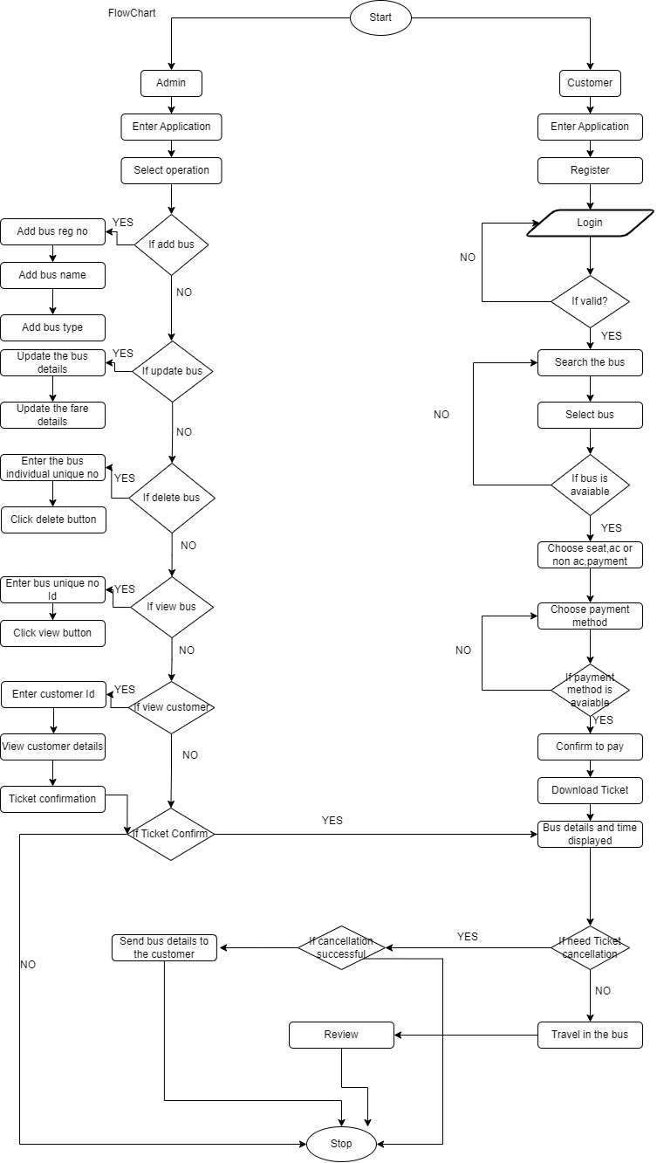

**W3H:-**

|  |  |  |  |
| --- | --- | --- | --- |
|  | **Problem statement:-Online Bus Reservation System** | | |
|  |  |  |  |
|  | **What ? 1** |  | **How ? 2** |
|  | 1. What are the functionalities or Modules Required?  **ANS:-** **1)**Admin **a)**Add the bus  **i)**What are the details want to add for the bus?  **ANS:- 1)**Bus No,Bus Name,Bus Image and Bus Unique No  **b)**Update the bus  **i)**What are the details want to update for the bus?  **ANS:- 1)**Change the Seat availability,Start and End Time,  Bus No,Bus Name  **c)**Delete the bus  **i)**What are the details want to delete for the bus?  **ANS:- 1)**Bus information,Bus details,Bus No,Bus Name,  Bus Image and Bus unique No  **d)**View / View all the bus details  **i)**What are the details want to view the bus details by the  user?  **ANS:- 1)**Start and End Time,Seat availability,destination,  Bus No,Bus Name,Bus Image  **e)**Add / Delete / Update / View fare details  **i)**What are the details needed for the fare details  **ANS:- 1)**Add or Delete or Update or View for  the particular bus  **f)**Add / Delete / Update / View customer details  **i)**What are the details needed for the customer details?  **ANS:- 1)**Add or Delete or Update or View for  the particular customer  **2)**User **a)**Register  **i)**What are the details needed for Register credentials?  **ANS:-**username,phoneno,email,and,password  **b)**Login  **i)**What are the details needed for login page?  **ANS:-**username,and,password  **c)**Search a bus  i**)**What are the details want to search a bus?  **ANS:-**BusNo,BusName,Price,AC or Non-AC,Start and End  Time  **d)**Book a bus  **i)**What are the details needed for book a particular bus?  **ANS:-**Select a starting and destination point,Passenger  details,and,seat no's  **e)**Cancel a bus  **i)**What are the details needed for cancel the bus?  **ANS:-**Payment refund  **f)**Payment  **i)**What are the details needed for payment method?  **ANS:-**Tax,cancel payment,upi,google pay  **g)**Review  **i)**What are the details needed for review for the user?  **ANS:**-Give the overall feedback about the bus  **h)**Travel History  **i)**What are the details wants in the Travel History?  **ANS:-**Customer details,Bus No,Bus Name,Travel time  ,Travel date |  | 1.Admin  a.Add the bus  i)Implement the add bus using Bus No  ii)Implement the add bus using Bus No,Bus Name  iii)Implement the add bus using Bus Name,Bus No,Bus unique No  b.Delete / Update / View the bus  i)Method to implement this with manually  entered the Bus unique No,Bus No,Bus Name  ii)Method to implement this with using dropdown menu  iii)Method to implement this with using total listout  menu that will show all the bus details with bus unique No  c.Add the customer  i)Implement using the customer Email  ii)Implement using the customer Email / Username  iii)Implement using the customer Email / UserName / Phone No  d.Delete / Update / View the customer  i)Method to implement this with manually entered the customer  detail and customer unique Id  ii)Method to implement this with dropdown menu  iii)Method to implement this with using listout menu that will show  all the customer details with their specific Id  2.User  a.Register / Login  i)Implement using Email / username  ii)Implement using Email / username / Phone No  iii)Implement using Email / username / Phone No / Captcha  b.Search a bus  i)Implement to search a bus using Starting and destination point  ii)Implement to search a bus using Starting and destination point  / Cost of the ticket(Price)  iii)Implement to search a bus using Starting and destination point  / Cost of the ticket(Price) / date of the travel  c.Book a bus  i)Implement to book a bus using seat availability  ii)Implement to book a bus using seat availability / Start and End  Time  iii)Implement to book a bus using seat availability / Start and End  Time / Cost of the ticket(Price)  d.Cancel a bus  i)Implement to cancel a bus using ticket Id  ii)Implement to cancel a bus using PNR No  iii)Implement to cancel a bus using Customer Care Call  e.Payment  i)Implement payment method for using UPI  ii)Implement payment method for using UPI / Net banking  iii)Implement payment method for using UPI / Net banking / Coupons  f.Review  i)Implement review using star rating  ii)Implement review using star rating / feedback  iii)Implement review using star rating / feedback / comments  g.Travel History  i)Travel History gave ticket Id  ii)Travel History gave ticket Id / date  iii)Travel History gave ticket Id / date / price |
|  |  |
|  |  |
|  |  |
|  |  |
|  |  |
|  |  |
|  |  |
|  |  |
|  |  |
|  |  |  |  |
|  | **1.**Admin  **a.**Add the bus  **iii)**Implement the add bus using Bus Name,Bus No,Bus unique No  **(If we use the specific unique No for each bus it will easy to filter out**  **the bus for anytime purpose)**  **b.**Delete / Update / View the bus  **iii)**Method to implement this with using total listout menu  **(If we use this listout menu method that is show all the necessary details**  **include Bus Name,Bus No,Bus unique No and that will easy to access the**  **details)**  **c.**Add the customer  **iii)**Implement using the customer Email / UserName / Phone No  **(If we use all the details is more authentication for securing their contacts)**  **d.**Delete / Update / View the customer  **iii)**Method to implement this with using listout menu  **(If we use this listout menu method it will show all the necessary details**  **include Customer details,Customer Name,Customer unique No and that will**  **easy to access the details)**  **2.**User  **a.**Register / Login  **iii)**Implement using Email / UserName / Phone No / Captcha  **(If the user will provide this all the details it will easy to secure the details**  **for the security purpose)**  **b.**Search a bus  **iii)**Implement to search a bus using Starting and destination point / Cost of the ticket  (Price) / date of the travel  **(If we implement the Starting and destination point / Cost of the ticket(Price) /**  **date of the travel customer easily able to access)**  **c.**Book a bus  **iii)**Implement to book a bus using seat availability / Start and End Time / Cost of the  ticket(Price)  **(If we provide to implement to book a bus using seat availability / Start and**  **End Time / Cost of the ticket(Price) its make customer to easily book a bus)**  d.Cancel a bus  **iii)**Implement to cancel a bus using Customer Care Call  **(If we use this customer can able to cancel a bus without tension)**  e.Payment  **iii)**Implement payment method for using UPI / Net banking / Coupons  **(If we implements all the options customer can able to pay their cash**  **without any issues)**  **f.**Review  **iii)**Implement review using star rating / feedback / comments  **(If we implements this all star rating / feedback / comments its**  **makes customer easily find out to choose the right bus)**  **g.**Travel History  **iii)**Travel History gave ticket Id / date / price  **(If we implements the ticket Id / date / price it will easily**  **see the history for the customer travel History)** |  | 1) To add the Bus it is not feasible to implement using bus name or no. because for  specific route the buses has similar name and no.  2) To delete the Bus details it is not feasible to delete using manually, because while  entering incase of mistakenly type one digit wrong then wrong bus details will deleted.  3) To implement the customer details with name and email means sometimes their will be  similar names it is difficult to track the particular user.  4) Registration with only one type is not feasible to everyone use the system.  5) Most of the Bus have similar names based on the specific route so it is not feasible.  6) While booking user can expect the seat availability and price range and travel time  so that they will book a ticket without any confusion. But specifying only one thing is  not feasible.  7) Cancellation of bus ticket is done by customer care and ticket no is not feasible. with  the help of PNR no user can able to cancell the ticket in system itself.  8) Implementing only one type of payment is not applicable.  9) While coming to single type of review user will lost the interest on giving the review,  having multiple option for reviews can enable the user to give reviews. |
|  |  |
|  |  |
|  |  |
|  |  |
|  |  |
|  |  |
|  |  |
|  |  |
|  |  |
|  | **Why ? 3** |  | **Why Not ? 4** |
|  |  |  |  |
|  |  |
|  |  |
|  |  |
|  |  |
|  |  |
|  |  |
|  |  |
|  |  |
|  |  |
|  |  |
|  |  |
|  |  |  |  |
|  |  |  |  |

**UML:-**

**Class Diagram:-**

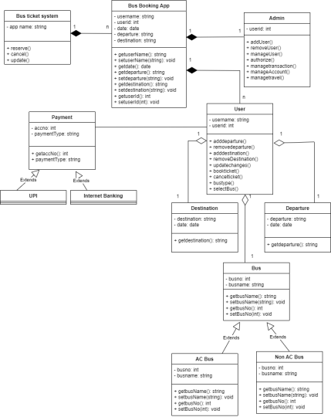

**Use case diagram:-**

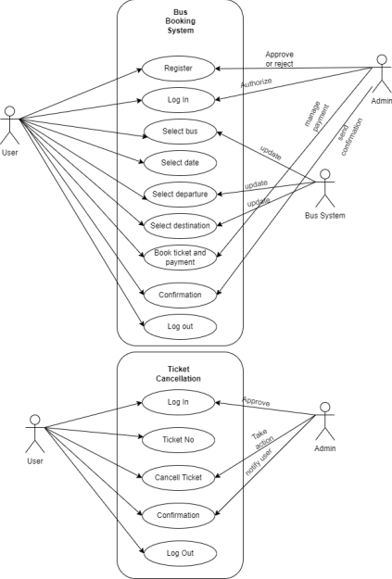

**Sequence diagram:-**

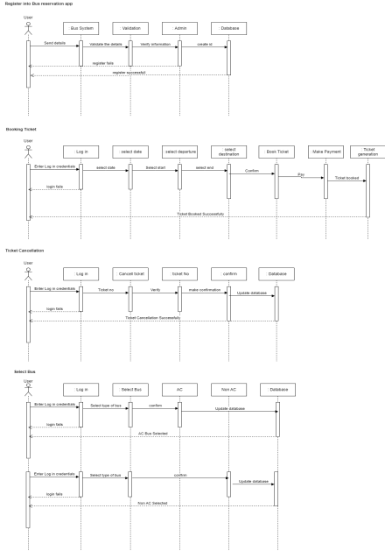

**State Chart diagram:-**

